PHYSICS 2005

YEAR 12
These test papers are copyright and may not be reproduced in any way.
 This paper should be withdrawn after use and stored securely in the school until Wednesday 19th October 2005.
Test papers may not be used for private tutoring before the above date.



Name:________________________________________Teacher:_________________________________

TIME ALLOWED FOR THIS PAPER:
Reading time before commencing work: Ten minutes
Working time for paper: Three hours

MATERIAL REQUIRED/RECOMMENDED FOR THIS PAPER

To Be Provided By The Supervisor
This Question/Answer Booklet comprising 39 pages.
Physics: Formulae and Constants Sheet (inside front cover of this Question/Answer Booklet).

To Be Provided By The Candidate
Standard Items: Pens, pencils, eraser or correction fluid, ruler.
Special Items: MATHOMAT and/or Mathaid, compass, protractor, set square and calculators satisfying the conditions set by the Curriculum Council.

IMPORTANT NOTE TO CANDIDATES
No other items may be taken into the examination room.

It is your responsibility to ensure that you do not have any unauthorised notes or other items of a non-personal nature in the examination room. If you have any unauthorised material with you hand it to the supervisor BEFORE reading any further.

STRUCTURE OF THE PAPER

Section | No. of  Questions | No. of questions to  be attempted | No of marks out  of 200 | Proportion of  Examination total
A: Short Answers | 15 | ALL | 60 | 30%
B: Problem Solving | 8 | ALL | 100 | 50%
C: Comprehension and  Interpretation | 2 | ALL | 40 | 20%

INSTRUCTIONS TO CANDIDATES

Write your answers in the spaces provided beneath each question. The value of each question (out of 200)
is shown following each question. You should note that the space made available for an answer is not
necessarily an indication of the length of the answer.

The enclosed Physics: Formulae and Constants Sheet may be removed from the booklet and used as required.

Answers to questions involving calculations should be evaluated and given in decimal form. It is suggested
that you quote all answers to three significant figures with the exception of questions for which estimates
are required. Despite an incorrect final result, you may obtain marks for method and working, provided
these are clearly and legibly set out.

Questions containing specific instructions to show working should be answered with a complete, logical,
clear sequence of reasoning showing how the final answer was arrived at. Correct answers which do not
show working will not be awarded full marks

Questions containing the instruction "Estimate" may give insufficient numerical data for their solution.
Students should provide appropriate figures to enable an approximate solution to be obtained.

When descriptive answers are required, you should display your understanding of the context of a question.
An answer which does not display an understanding of Physics principles will not attract marks.

This page has been intentionally left blank

Section A: Short Answers

Marks allocated: 60 marks out of a total of 200 (30%)

Attempt ALL 15 questions in this section. Each question is worth 4 marks.
Answers are to be written in the space below or next to each question.

1 A child watching a toy boat’s movement in a pond notices the boat bobs up and down in the water
as regular waves pass by. She counts 15 complete oscillations in 10 seconds.
What is the period of the waves?

2 Why are sound waves known as longitudinal waves but light waves are known as transverse waves?

3 A teacher demonstrates parabolic motion to her class by throwing a tennis ball horizontally. The class members notice that the ball curves downwards immediately it leaves the teacher’s hand. Explain why the ball travels in that way.

4 Satellites orbiting freely around the Earth are sometimes placed in equatorial orbits (diagram A) and sometimes in polar orbits (diagram B). Explain why the orbits in diagram C are physically impossible for satellites.
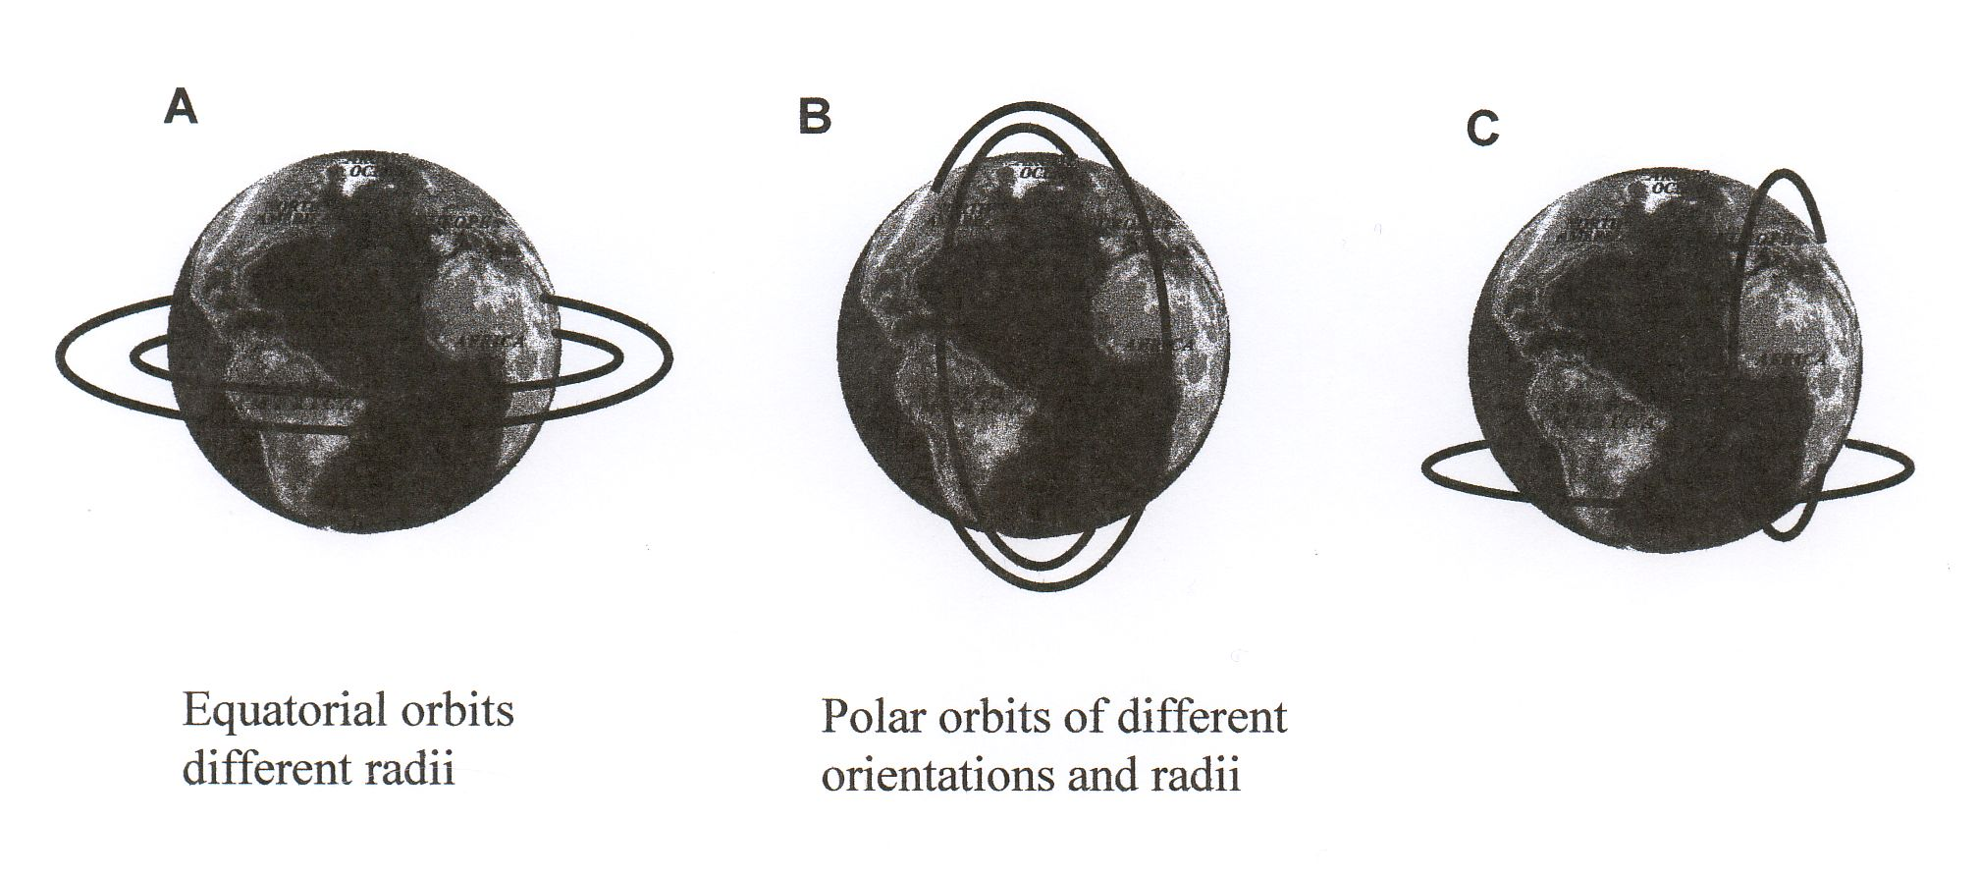

5 The line emission spectrum of sodium consists of several bright lines on a dark background whereas the absorption spectrum of sunlight consists of discrete dark lines on a coloured background. Explain this difference.

- Indoor cycling tracks are banked so riders travel faster than if the track was not banked.
What is the maximum speed a cyclist could travel around a curve that has a radius of curvature of 27.5 m and is banked at an angle of 42º to the horizontal?

7 The diagram shows some energy levels, in eV, of an atom.

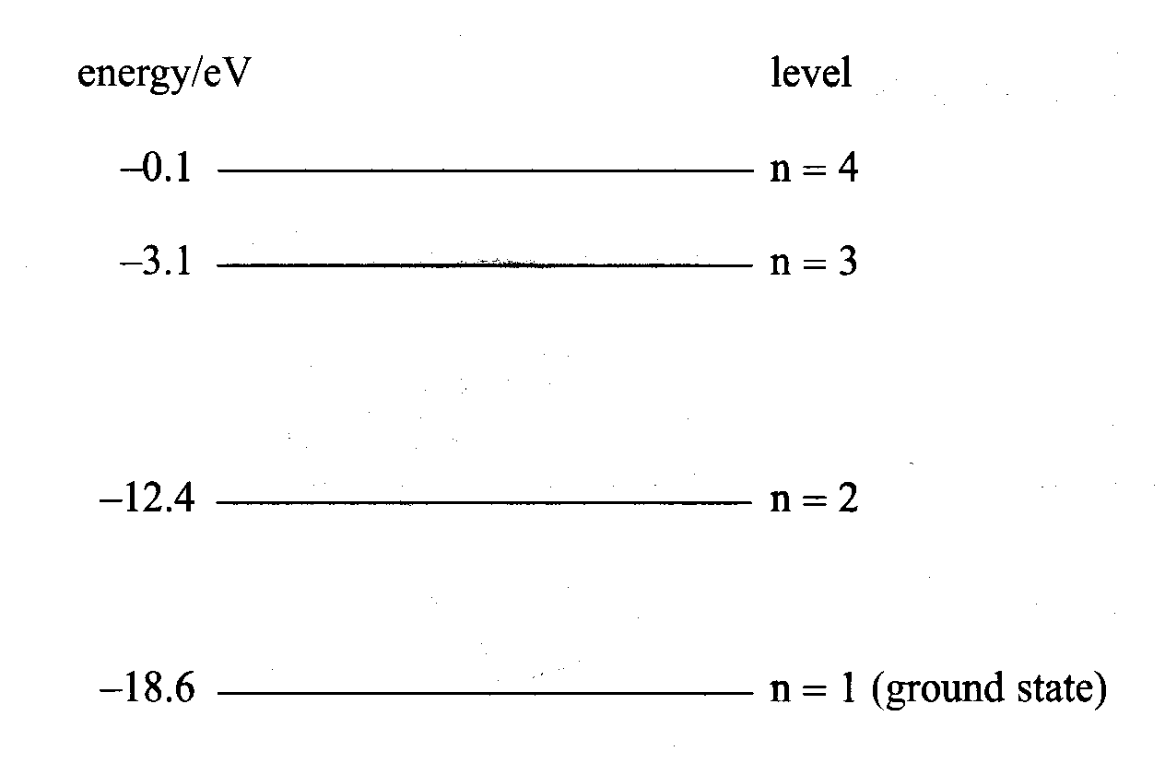

Photons of specific wavelengths are emitted from these atoms when they are excited by collisions with electrons.

One of the emitted photons has an energy of 9.92 x 10⁻¹⁹J.
a) Determine which transition is responsible for this emitted photon.

b) Draw an arrow on the energy level diagram to show the transition responsible for the emission of a photon with the shortest wavelength.
- A hump back bridge is constructed so it has a radius of 50.0 m. What is the maximum speed a motorcyclist can travel across the bridge without ‘lifting off the bridge’?
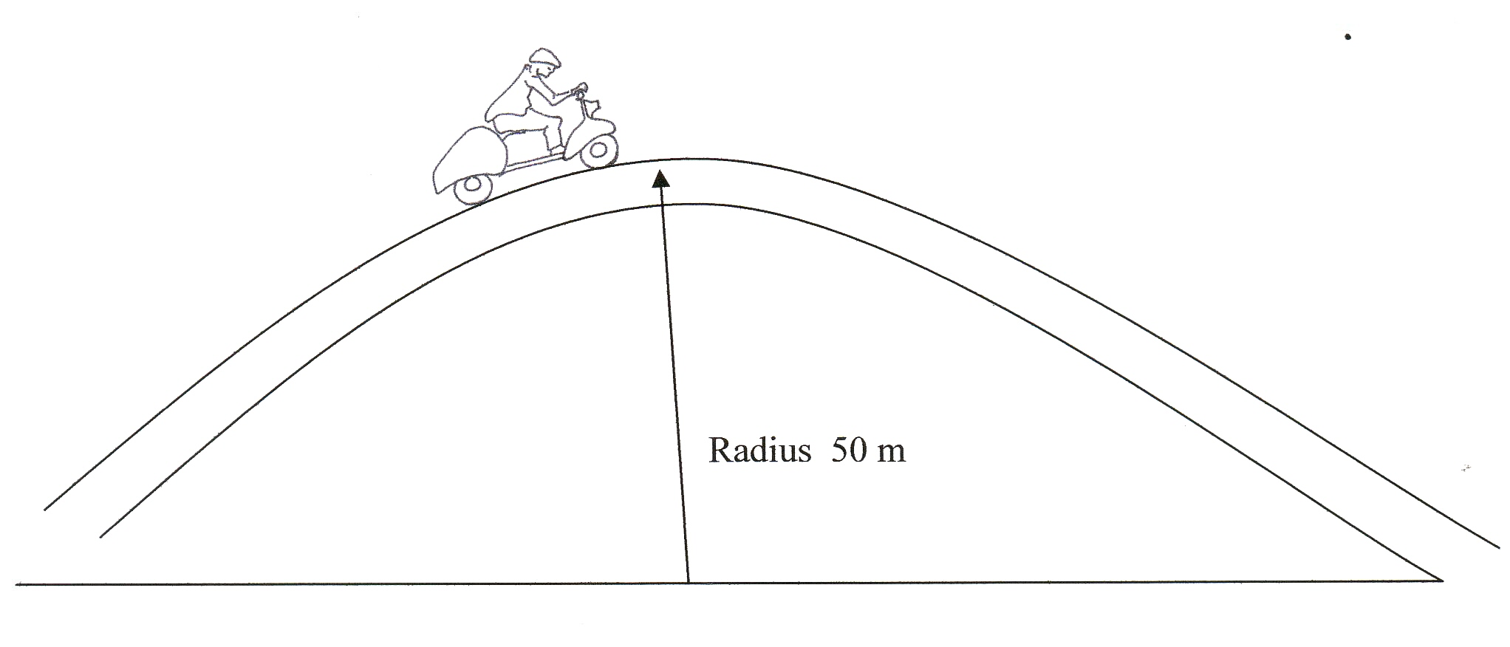

9 (a) A bus stop shelter has overhanging roof beams. Each beam is uniform and is held in place by two large columns, X and Y, fixed in a solid foundation as shown below.

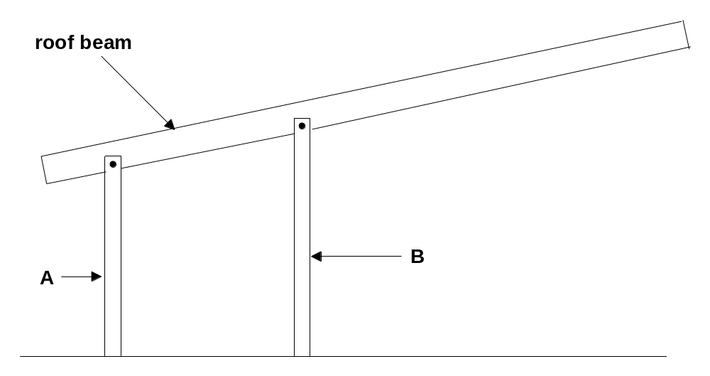

(i) Which of the following best describes the stresses in the columns A and B? (1 mark)

A A is in compression and B is in tension.
B A is in tension and B is in compression.
C A and B are both in tension.
D A and B are both in compression.

(ii) Each roof beam will be made of reinforced concrete. Carefully sketch where the reinforcement should be put in the roof beam, and give a written explanation for putting it in this position. (3 marks)

10 Electric power is transmitted over long distances by cables
consisting of aluminium alloy wires surrounding a steel core,
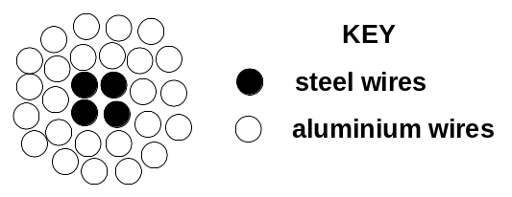
as shown in the diagram to the right. A typical power cable
consists of a steel core of 4 wires surrounded by 24 aluminium
wires. Each of the steel and aluminium wires has a
cross-sectional area of 10.0 mm².

Explain briefly why the power cable made of a combination of steel and aluminium wires is preferable to a cable made of aluminium only, even though aluminium is a better conductor.

- The properties of the aluminium alloy used in Q10 above are shown in the graph below.
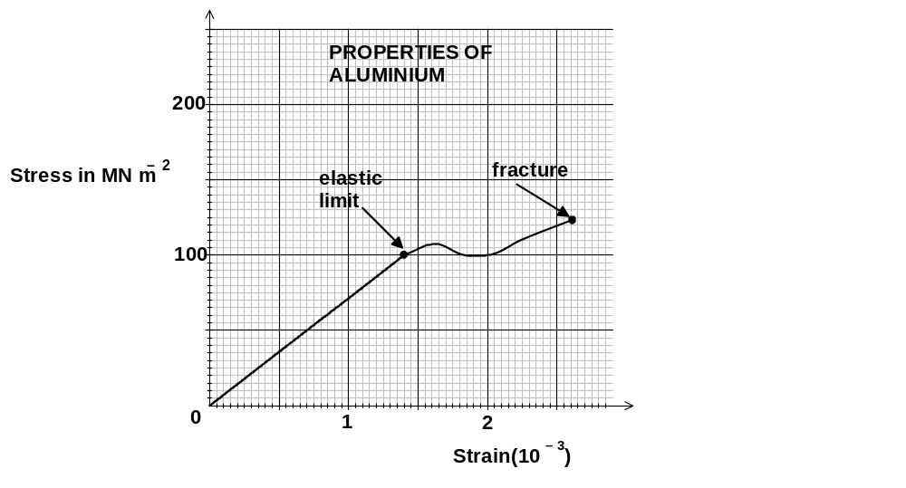

(i) Calculate the value of Young’s Modulus for aluminium alloy. (1 mark)

(ii) Neglecting the steel wires, if a force of 12500 N is applied to a 100 m long aluminium alloy cable consisting of the 24 wires, by how much would it stretch? (3 marks)

12 A step down transformer is used to operate a battery recharger. It is designed to reduce 240 V mains supply to 3 V. If the primary coil has 1200 turns, how many turns should the secondary coil have?

13 A tuning fork of unknown frequency was sounded at the top of a column. The water was allowed to gradually run out through a tap in the bottom of the column. A louder sound was heard when the water level was 17.0 cm from the top. What was the frequency of the tuning fork?

- A trades person leans a ladder against the gutter of a house and is careful to make the angle
between the ground and the ladder as large as practical.
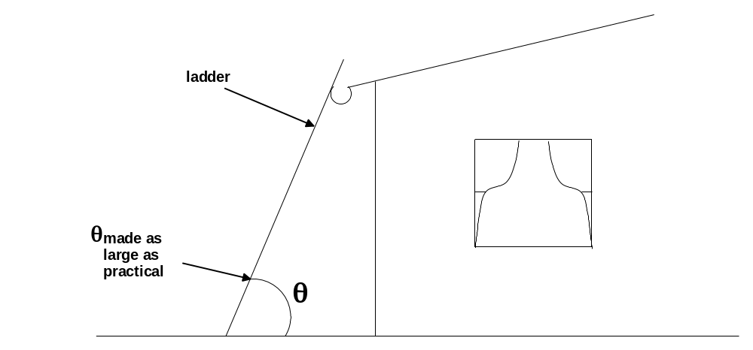

a Why is the ladder less likely to slip when the angle θ is large rather than smaller? (2 marks)

b On the diagram below use arrows to show all the forces on the ladder. (2 marks)

15 An electron is travelling in a southerly direction with a velocity of 3.0 x 10⁶ m s⁻¹ and enters
the Earth’s magnetic field where the vertical component is 2.0 x 10⁻³ T towards the earth.
What is the initial magnitude and direction of the force on the electron?

Section B: Problem Solving

Marks allotted: 100 marks out of a total of 200 (50%).

This section contains 8 questions.

You should answer: ALL of the questions.

Answer the questions in the spaces provided

- (18 marks)

In preparation for a sports day, a microphone and an amplifier are connected to a pair of speakers and located on the school oval.

a) For testing purposes, a signal of constant amplitude and frequency is fed to one of the speakers, S1. If the speaker emitted 1.8 x 10 ⁴ J of sound energy in one minute, at what power is it producing sound? (2 marks)

- At the side of the track, sound power of 5.0 x 10⁻⁹ W reaches an athlete’s ear drum of area
4.0 x 10⁻⁵ m². What sound intensity level is the athlete experiencing? (3 marks)

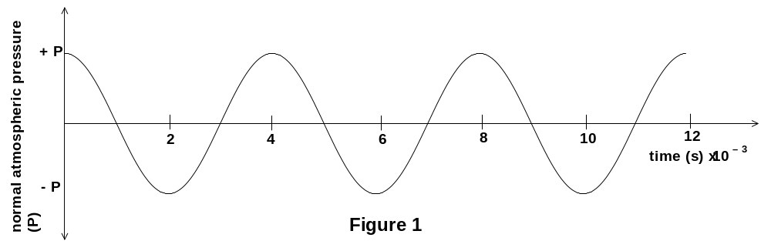 c) An oscilloscope connected to a microphone placed near the track indicates that the sound pressure varies with time as shown in Figure 1 below.

(i) What is the period of the wave? (2 marks)

(ii) What is the wavelength of the sound? (velocity of sound on the day is 346 m s⁻¹.)
(3 marks)

(iii) If the air temperature increased during the sports day, what would happen to the value of the wavelength of the sound? Explain your answer. (2 marks)

d) A second, identical speaker S2 is then connected so that it operates in phase with the first speaker S1. See Figure 2.
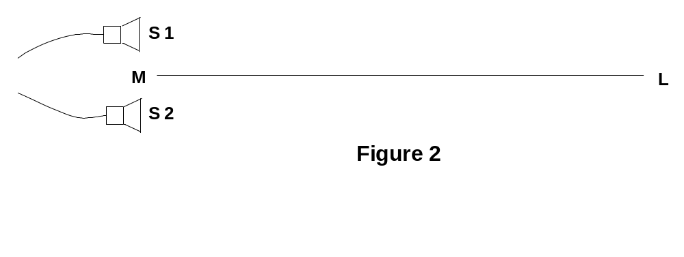

A sound of constant intensity with constant frequency is emitted by both speakers. During this time, an athlete walks towards the speakers along the line LM. Which of the following best describes what she hears? (2 marks)

A. no sound at all (or a very soft sound).
B. a sound of increasing frequency.
C. a sound of decreasing frequency.
D. a sound of constant frequency but increasing volume.
E. an alternating series of loud and soft sounds.

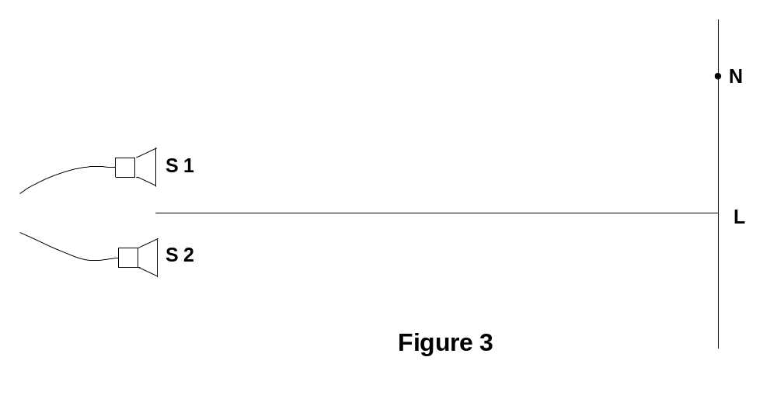e) Another athlete is at point N which is 24.60 m from S1 and 28.75 m from S2. Show your working in the space provided.

She experiences:

A. a maximum intensity sound.
B. a minimum intensity sound.
C. a sound level which fluctuates at the frequency of the sound.
D. neither a minimum nor maximum. (4 marks)

Show working here

- (10 marks)
The Figure below shows the rotor-blade arrangement used in a model helicopter. Each of the rotor blades is made from aluminium and is 55.0 cm long with a uniform cross-sectional area of 3.5 cm² and negligible mass. An end-cap of mass 1.5 kg is attached to the end of each blade. The centre of mass for each blade is 30.0 cm from the centre.

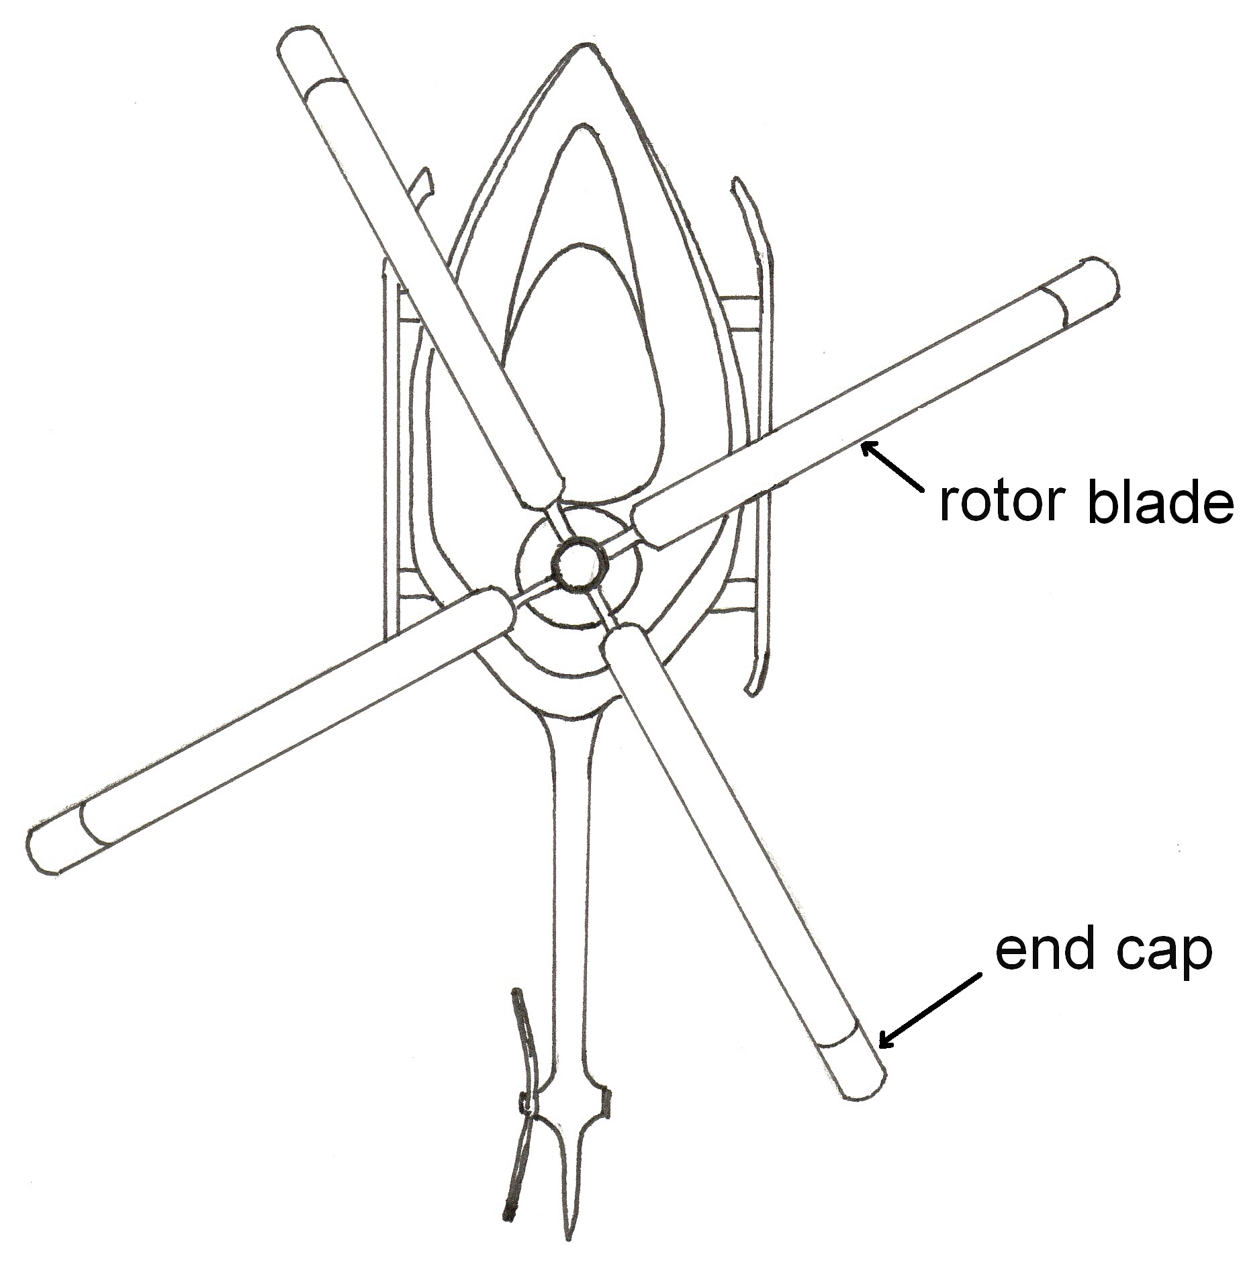

For part (a) the helicopter is sitting on the ground and the blades are rotating horizontally.

a) (i) Show that there is a force of about 7 kN acting on each end-cap when the blades rotate at 15 revolutions per second. (3marks)

(ii) Show that this force leads to a longitudinal stress in the blade of about 20 MPa.
(2 marks)

(iii) Calculate the change in length of the blade as a result of its rotation.
(3 marks)

For part (b) the helicopter is flying through a steep turn and the rotor blades are rotating vertically.
Which blade is experiencing the greatest force as the blades rotate?
Explain your answer. (hint: a diagram may help explain your answer) (2 marks)

- (10 marks)

(a) The Figure below shows a model of a railway bridge, constructed of bolted lengths of timber, all forming 60° angles. The weight of the bridge and any traffic can be taken as acting at point C in the middle of the bridge. The length of the bridge is 5.0 m.
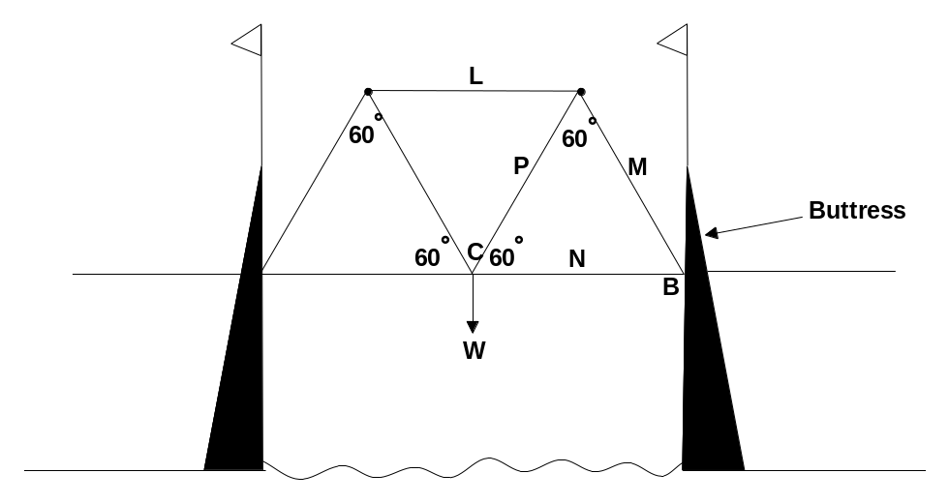

(i) List 2 advantages of using a truss in a railway bridge. (2 marks)

(ii) If the weight of the bridge and traffic is 5.00 x 10⁵ N, what is the magnitude of the force applied by the buttress through length M? (4 marks)
Assume no horizontal force is applied to CB by the buttress.

(b) The boom of a particular yacht is a uniform aluminium rod XY of length 5.00 m and mass 8.00 kg. End X of the boom is joined to the mast by a connection that allows the boom to tilt up or down. The end Y of the boom is connected by a wire W to the top of the mast. This wire has a tension of 200 N and makes an angle of 60° to the horizontal. The boom is held horizontal by a force T acting vertically downwards in a rope R attached to the boom 2.0 m from the end B.
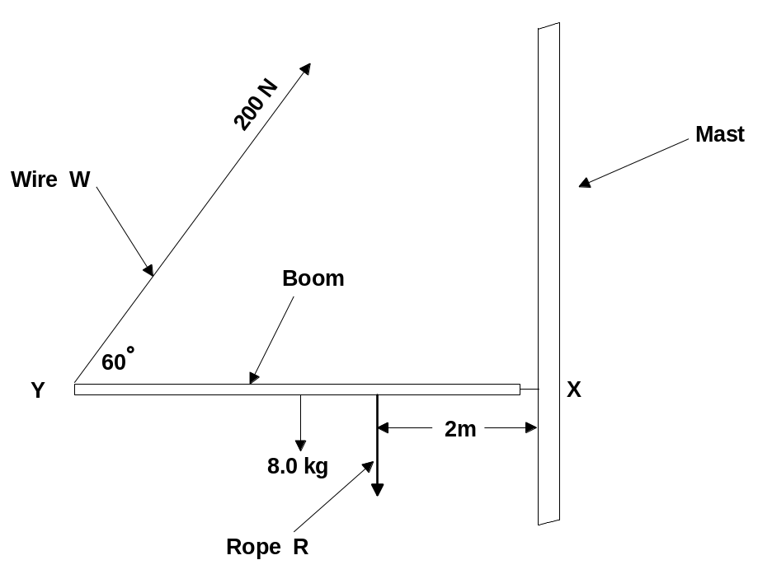

(i) Calculate the size of the tension force in the rope R. Show your working.
(4 marks)

4 (14 marks)
(a) In the apparatus shown in the sketch, a beam of singly-charged positive ions
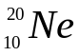, 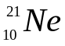, 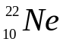 ions passes through the slits P and Q and enters the evacuated
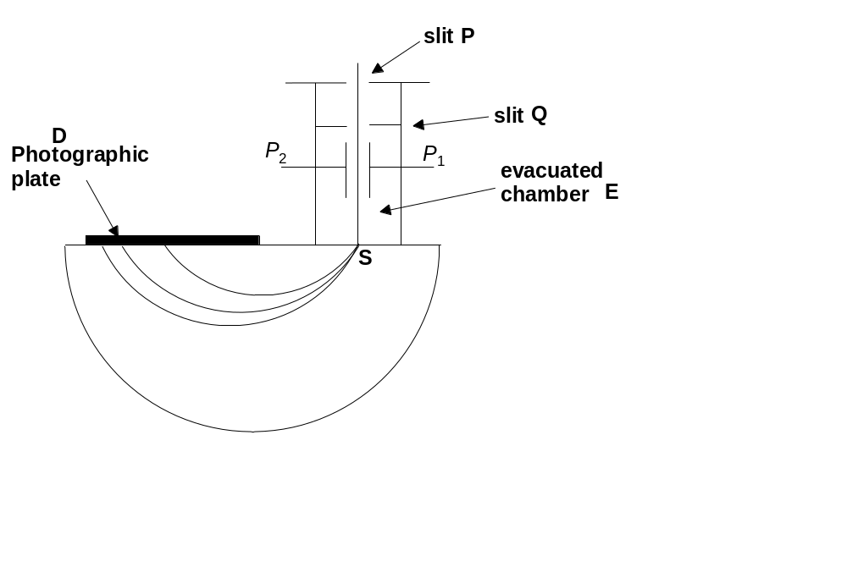 chamber E. A uniform magnetic flux is applied throughout E.

- If the magnetic field is of flux density 0.60 T and the force on the ions is
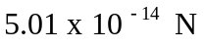, find the velocity of the ions that emerge from S. (2 marks)

(ii) The ions of one isotope form a trace on the photograph plate D at a distance of
38.0 cm from the slit S. Find the mass number of the isotope. (6 marks)
1 u = 1.66 x 10⁻²⁷ kg
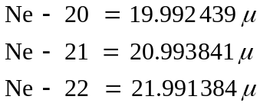

(b) Consider an incandescent lamp and a low pressure sodium vapour lamp. Discuss each of these with respect to the following properties. (6 marks)

 | incandescent lamp | low pressure sodium vapour lamp
Method of producing light
Details of spectrum
Use

5 (11 marks)
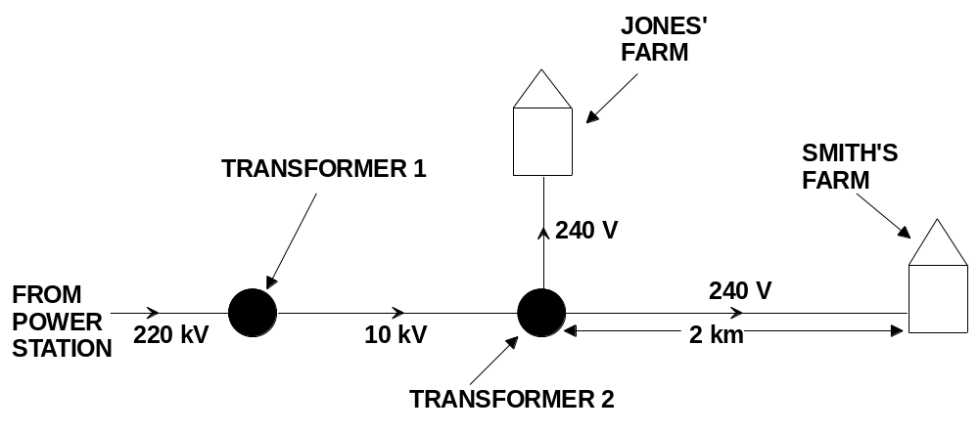 A farming community relies upon a power station more than 100 km away for its electricity. It is carried by transmission lines at a voltage of 220 kV. The Smith and Jones families live near the town and are supplied with electricity. A transformer 1 steps the voltage down to 10 kV for the local area. A 10 kV line runs to the Jones’ farm, where transformer 2 provides 240 V for the farms. A 240 V line then runs 2 km to the Smith’s farm. A sketch of the situation is shown.
The transformers can be considered to be ideal.

a) Assuming that the input voltage to transformer 1 is 220 kV and that the power station supplies power at 0.5 MW, and that the output is 10 kV, calculate
(4 marks)
- the value of the ratio:
number of turns on the primary coil
number of turns on the secondary coil

(ii) the current in the secondary coil of transformer 1

b) The supply and the return lines between transformer 2 and the Smith’s farm have a total resistance of 4.0 x 10⁻⁴ ohm m⁻¹. At a particular time, 2 motors and lighting, all connected in parallel and drawing currents of 9.0 A, 4.0 A and 3.0 A respectively, are being used at the Smith’s farm.
- How much power is lost in the transmission lines? (3 marks)

(ii) Calculate the voltage at the Smith’s farm. (4 marks)

6 (8 marks)
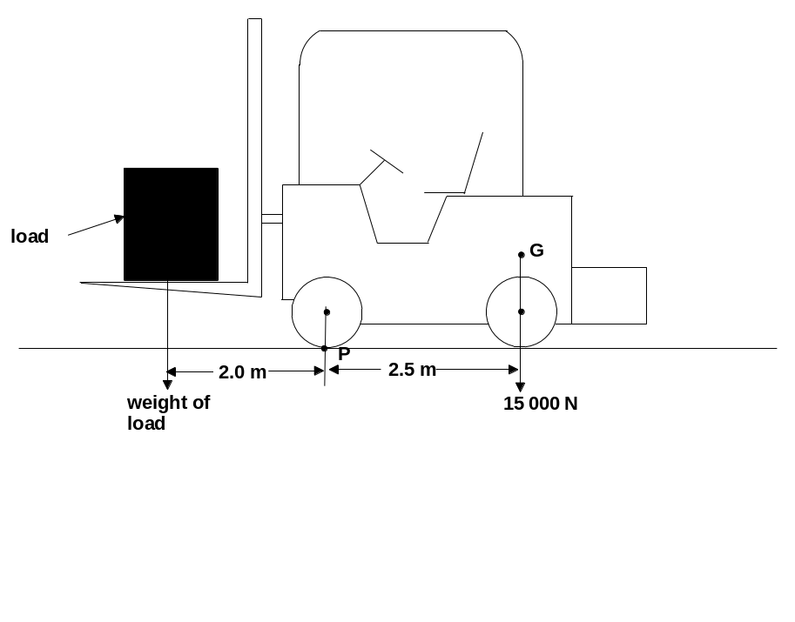 The figure below shows a fork-lift truck of weight 15 000 N lifting a load. The weight of the unloaded truck acts through the centre of gravity G, and the weight of the load acts through point L as shown. P is the point about which the truck pivots if the load is too heavy. The distances from P to the vertical lines through G, and L are as shown.

a) Calculate the moment of the weight of the truck about P. (2 marks)

b) Calculate the maximum load which the truck can carry before it tilts about P
(2 marks)

c) The truck needs to lift the load through a vertical height of 1.5 m in 2.5 s. How does this affect your answer to (b)? Explain briefly. (2 marks)

d) Briefly explain why centre of gravity G is not shown at the centre of the truck.
(2 marks)

7 (15 marks)

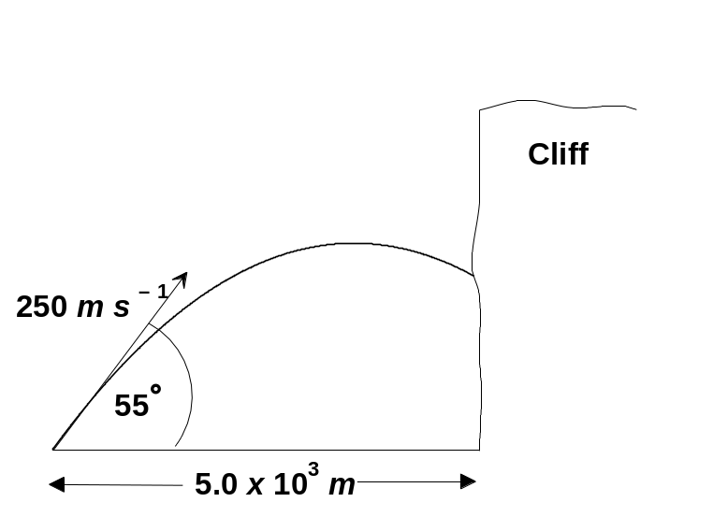 A projectile is fired with a muzzle velocity of 250.0 m s⁻¹ at an angle of elevation of 55° above the horizontal, as shown.

(a) Neglecting air resistance,
(i) At what height will it strike a vertical cliff distant 5.0 x 10³ m horizontally from the gun? (6 marks)

(ii) Find the magnitude and direction of its velocity when it strikes. (5 marks)

b) An observer notices that the projectile hits the cliff slightly lower than that calculated in (a) above.

(i) Suggest and explain a reason for this. (2 marks)

(ii) The operator of the gun now aims the gun at an angle of 45° to the horizontal in the hope that the projectile would land on the top of the cliff. Discuss the possibility of the projectile landing on the top of the cliff under these circumstances. (no calculation required) (2 marks)

8 (14 marks)

Using an electric motor kit a student assembles a model motor.
In the kit are the following components:
A 15 turn rectangular coil 5.0 cm x 3.0 cm mounted on an axle
A pair of magnets
A pair of brushes
A commutator
Electrical leads

A power pack was available to supply the electric current.
The diagram below shows the assembled motor.
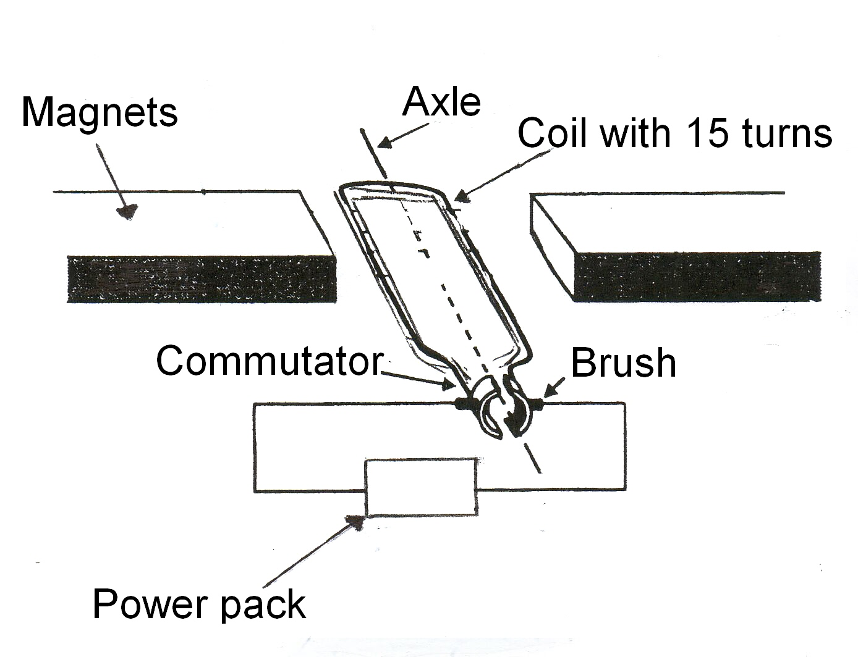
When assembled and tested it was found that a current of 1.5 A was required to turn the coil in a magnetic field of 1.0 x 10 ⁻³ T.

(a) Calculate the force exerted on one of the 5.0 cm sides of the coil. (3 marks)

(b) What additional measurement would the student need to make if he wanted to calculate the torque of the motor in the horizontal position? (1 mark)

(c) In which position (vertical or horizontal) will the coil experience maximum torque? (1 mark)

(d) Explain your answer to (c) above. (2 marks)

(e) Calculate the maximum torque of the motor. (2 marks)

(f) List four ways in which the motor could be modified so the maximum torque could increased (2 marks)

(g) Motors can be used as generators if they are modified in a certain way. How could this motor be converted into a generator? (2 marks)

(h) If the motor was modified and converted into a generator, would the generator produce
AC or DC current? (1 mark)

Section C: Comprehension and Interpretation

Marks allotted: 40 marks out of 200 (20%)

SECTION C: Comprehension & Interpretation
Marks allotted: 40 marks out of 200 marks total (20%)
BOTH questions should be attempted.

Read both passages carefully and answer all of the questions at the end of each passage. Candidates are reminded of the need for correct English and clear and concise presentation of answers. Diagrams (sketches), equations and/or numerical results should be included where appropriate.

1 Music and the Acoustics of Buildings [Total 20 marks]
(Paragraph 1)
Basic principles
When a new lecture theatre was opened at Harvard University in 1895 it proved to be very difficult for the lecturer to make himself heard. The President suggested that the Professor of Physics, W C Sabine, should “do something about it”.

(Paragraph 2)
The core of his theory is that the product of the absorption present in a room and the time taken for a sound to decay is constant. But before discussing this let us consider a very basic model of what happens to sound in a room. A person suspended in the air trying to communicate with another person, also suspended in the air has considerable problems because sound waves spread spherically and the inverse square law obviously applies. But, if they both stand on the ground, communication is helped by reflection; the addition of a wall behind the speaker gives further reinforcement. An increase in intensity of 25% in this situation would be a reasonable estimate.

(Paragraph 3)
Following the same argument it follows that if the speaker and listener are completely surrounded by walls there is an infinite series of reflections as the sound rebounds from wall after wall. If the reflectivity were 100%, then clearly the sound would go on for ever and we should have an impossible situation. Obviously, in practice, the reflection is nowhere near perfect, and one can see straight away that some kind of balance has to be struck between using reflection to enhance the sound level without prolonging the sound so long that each successive syllable or word overlaps the previous ones and destroys intelligibility.

(Paragraph 4)
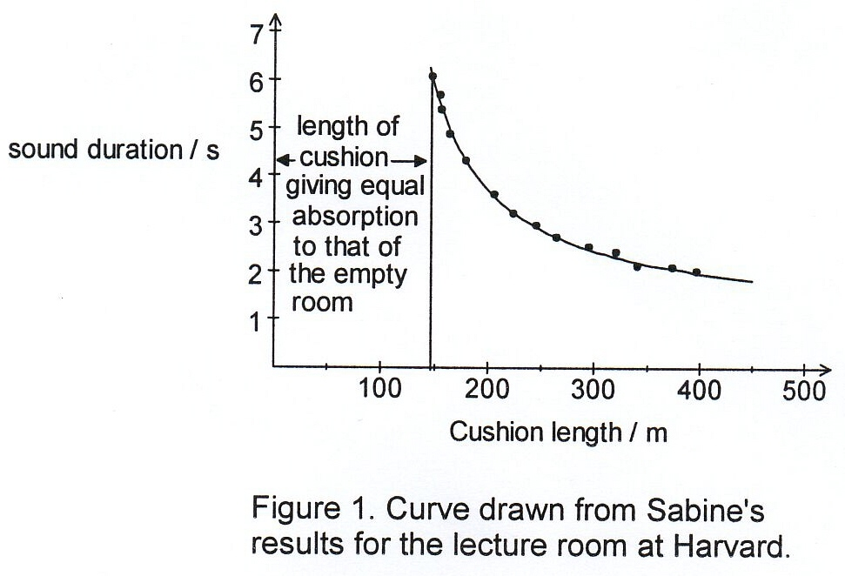
Sabine's work involved finding the criteria for this
balance between adequate sound levels and good
intelligibility. He used the persistence time of the
sound after an organ pipe had stopped sounding to
measure the effectiveness of the absorbent and
began to calibrate the absorption of people, carpets,
curtains etc in terms of “cushion length”.
The technique was to measure the persistence
time with certain absorbents present, then to replace
them with cushions and find out what length of
cushion would reproduce the same persistence time.

(Paragraph 5)
But he needed some more absolute measure than cushion length and he realised that an open window “absorbs” all the sound falling on it and so the cushions could be calibrated in terms of square metres of open window. He very soon evolved the formula which is still the basis of acoustic design:

(a + x) T = k V…………………..equation (1)
Where
V volume of the room,
T “time of reverberation”,
a initial absorption of the room and
x the amount added by cushions or other absorbents.

The constant k, which is valid for a surprisingly wide range of rooms, has a value of 0.171 if the dimensions are in metres.

(Paragraph 6)
Further basic physics
What the “time of reverberation” ought to be depends on the use for which the hall is being designed. From the physics point of view it means that we must consider the effect that the frequencies present in the sounds being used have on the problem. Absorption is frequency-dependent. Generally speaking it is much easier to absorb the high frequencies than the lower ones.

(Paragraph 7)
But what value ought T to have? Obviously it is largely a matter of subjective judgment and the acoustic engineer needs a great deal of experience in selecting appropriate values for particular circumstances. However, figure 2 gives some fairly typical values as a starting point.
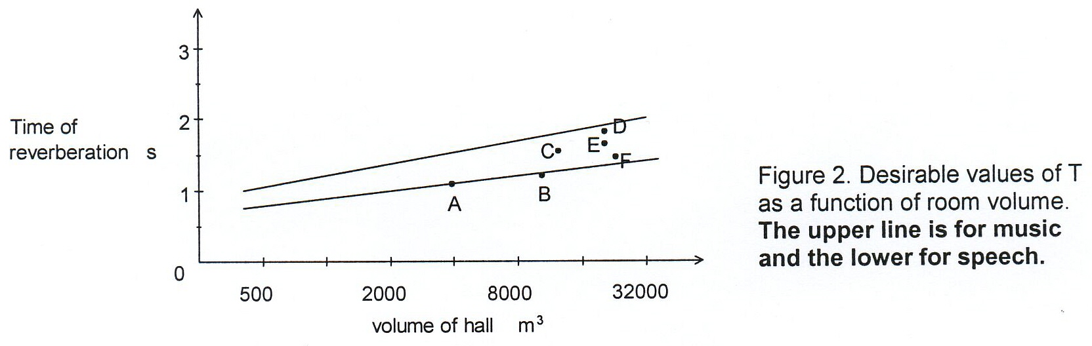

Questions

- (a) Estimate the difference in sound intensity that would be experienced by a person 5 m away from a 20 W speaker at full output for two different positions of the speaker:
Position One: On a level, hard reflective surface
Position Two: Suspended freely in the air
Show your assumptions and reasoning in arriving at your answer. (para 2) (5 marks)
[Surface area of sphere = 4πr² ]

- (b) What is reverberation, and why is it undesirable in lecture theatres and concert halls?
- (para 6) (3 marks)

(c) What is the initial absorption of a hall which has a volume of 8 000 m ³and a reverberation time
of 1.1 s, in the absence of any added absorbents? (para 5) (3 marks)

- (d) What does the phrase “absorption is frequency dependent” mean in the context of this article? (para 6) (3 marks)

(e) Explain the physical meaning of the shape of the “cushion curve” (Figure 1) and (para 4)
(3 marks)

(f) What is a desirable reverberation time for speech in a hall with a volume of 2 000 m ³
(Figure 2) and (para 5) (1 mark)

(g) Why is the desirable reverberation time for music greater than for speech? (para 6)
(2 marks)
2 The Trebuchet [Total 20 marks]
(para 1)
The trebuchet was used as a war machine as early as the seventh century to project missiles over the walls of fortified castles. It relies upon the principle of levers and a falling load to project rocks and arrows over long distances. The series of diagrams in Figure 1 shows how the mechanism works. It consists of a lever arm pivoted about a fulcrum. Energy is stored in the system by raising a heavy counterweight. When the counterweight is allowed to fall the stored energy is transferred to the sling containing the missile. During the transfer the lever arm is lifted, accelerated and the missile is released from the sling. The angle of release of the missile can be varied.
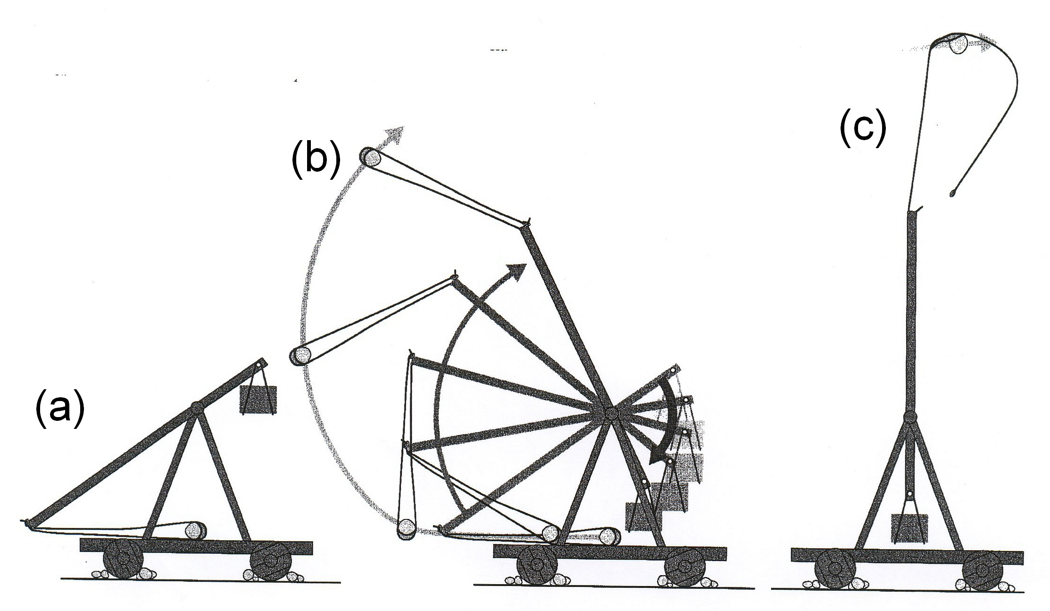

Figure 1
(para 2)
It is possible to predict how far the missile will travel and the height it will reach by using some fairly simple physics concepts. The principle of the conservation of energy suggests that if all the energy of the raised counterweight is transferred to the missile then a simple equation can represent this principle.

Decrease in PE of counterweight = increase in KE of missile + increase in PE of missile
(where PE is gravitational potential energy and KE is kinetic energy)

In symbolic form the equation is:
M g H = ½ m v² + m g h ………….(equation 1)

(where M is the mass of the counterweight and H is the distance the counterweight falls)

The above equation is too simplified to enable the operators of the trebuchet to predict accurately the range of the missile when it is launched. The equation assumes that the lever arm and the counterweight stop dead when the missile is released. In reality this would not be the case.
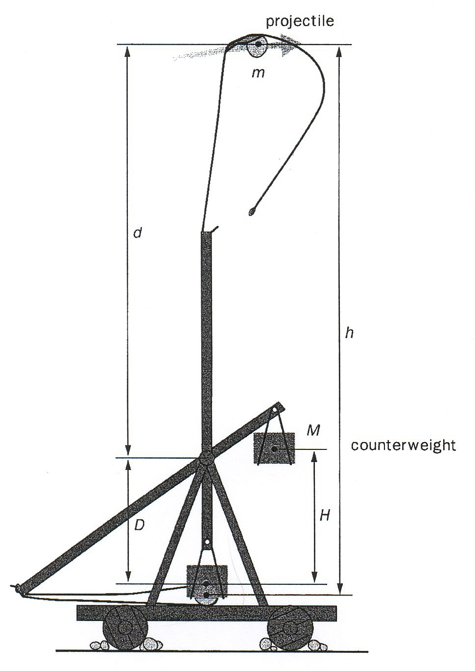
Figure 2

(para 3)
In practise the counterweight speeds up as it falls and therefore retains some of its energy, ½ M V² .
(where M the mass of the counterweight and V is the velocity of the counterweight at the instant the missile is released.)

So the new launch equation now becomes:
M g H = ½ M V² + ½ m v² + m g h ………..(equation 2)
(where V is velocity of counterweight)

(para 4)
Some of the variables in the new launch equation can be physically measured (refer to Figure 2) but the launch velocity cannot be calculated because there are two unknown quantities in the equation, the velocity of the counterweight (V) and the launch velocity (v) of the missile. Some fairly complex mathematics would be required to calculate the launch velocity precisely. Trial and error was used in ancient times to calculate the range and height if the launch velocity was unknown.

Questions
(a) What angle of release of the missile would provide the greatest range on level ground?
(1 mark)

(b) If the missile was launched horizontally, as in Figure C, from a height of 16.0 m above the ground with a velocity of 17.2 m s⁻¹, how long would it be in the air before it landed if the ground was level? (para 2) (4 marks)

(c) If the missile was launched under the same conditions as in (b) above, how far would it travel horizontally (its range) if the ground was level? (para 2) (3 marks)

(d) If the ground was not level and the missile landed 30.0 m below its launch height, would its horizontal range be greater or less than what was calculated in (c) above? Explain your answer but no calculation required. (para 1 ) (3 marks

(e) List the variables in the new launch equation that can be physically measured by the operator of the trebuchet. (para 3 ) (2 marks)

(f) Use equation 1 to calculate the approximate launch velocity of a 60.0 kg missile that is launched by a 800.0 kg counterweight falling a distance of 4.0 m. The missile is launched horizontally after travelling 16.0 m vertically (see Figure 2) (4 marks)

(g) If the mass of the counterweight was increased and all other conditions were kept constant, what would be the effect on the range of the missile projected by the Trebuchet? Explain your answer. (para 2) (3 marks)

END OF EXAMINATION

